* **The Fourier transform of an analogue signal x(t) is given by:**



* **The Discrete Fourier Transform (DFT) of a discrete-time signal x(nT) is given by:**



Where:





**x[n] = input**

**X[k] = frequency bins**

**W = twiddle factors**

**X(0) = x[0]WN0 + x[1]WN0*1 +…+ x[N-1]WN0*(N-1)**

**X(1) = x[0]WN0 + x[1]WN1*1 +…+ x[N-1]WN1*(N-1)**

**:**

**X(k) = x[0]WN0 + x[1]WNk*1 +…+ x[N-1]WNk*(N-1)**

**:**

**X(N-1) = x[0]WN0 + x[1]WN (N-1)*1 +…+ x[N-1]WN (N-1)(N-1)**

**Note: For N samples of x we have N frequencies representing the signal.**

**Performance of the DFT Algorithm**

* **The DFT requires N2 (NxN) complex multiplications:** 
  + **Each X(k) requires N complex multiplications.**
  + **Therefore to evaluate all the values of the DFT ( X(0) to X(N-1) ) N2 multiplications are required.**
* **The DFT also requires (N-1)*N complex additions:**
  + **Each X(k) requires N-1 additions.**
  + **Therefore to evaluate all the values of the DFT (N-1)*N additions are required.**

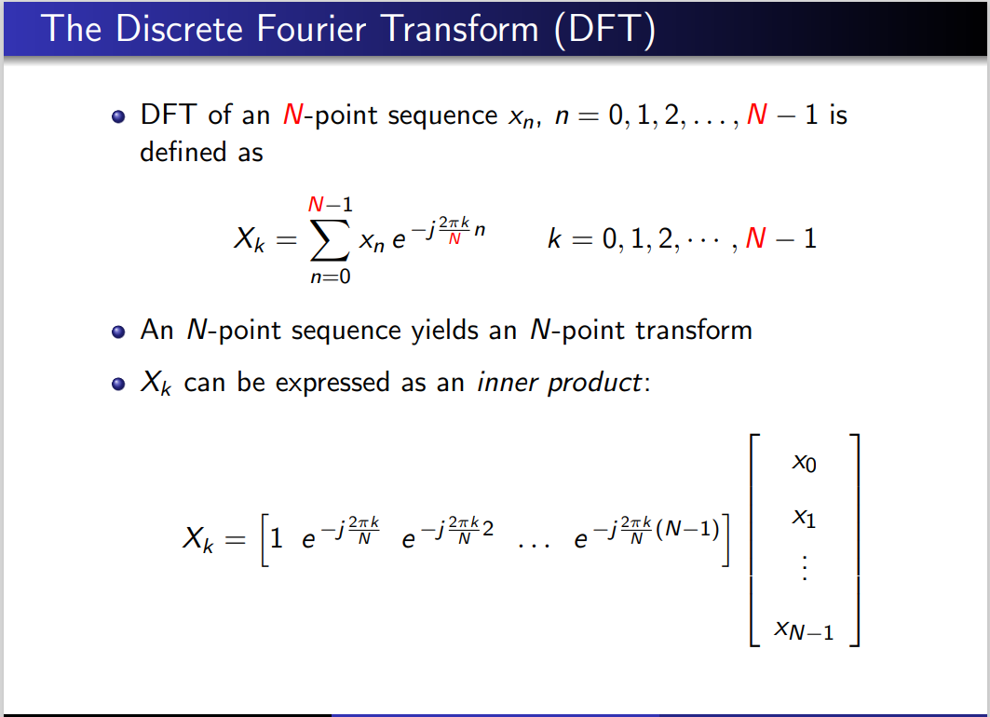

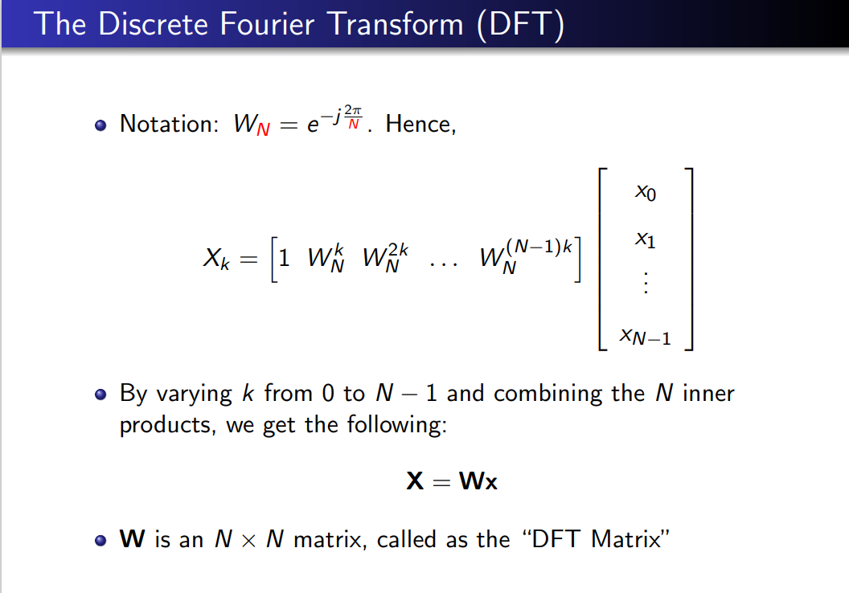

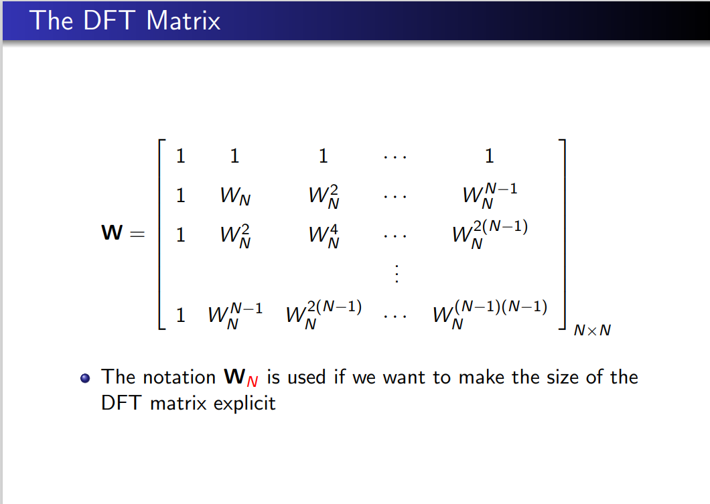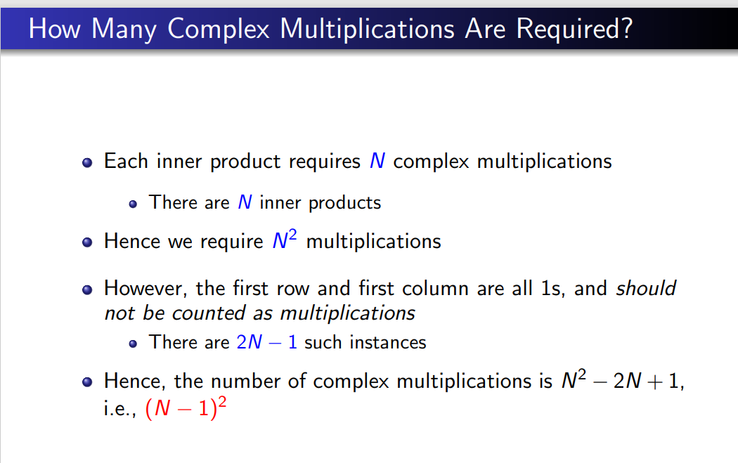

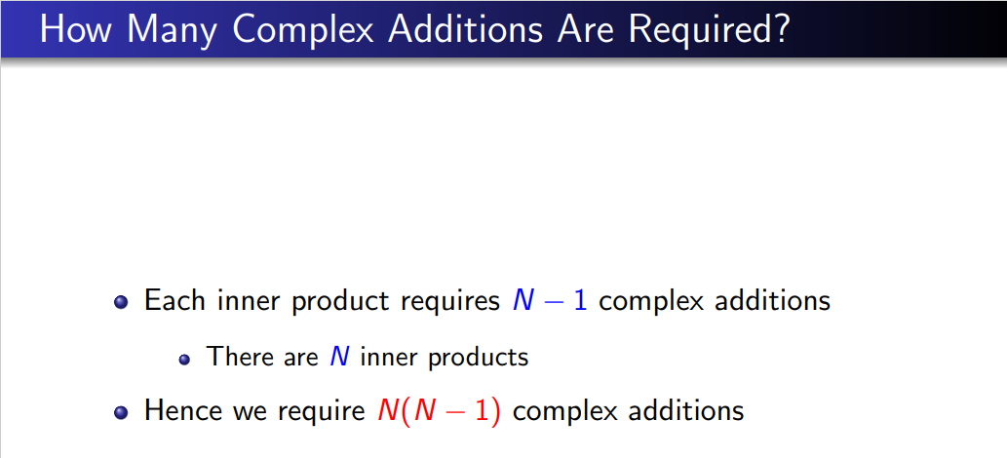

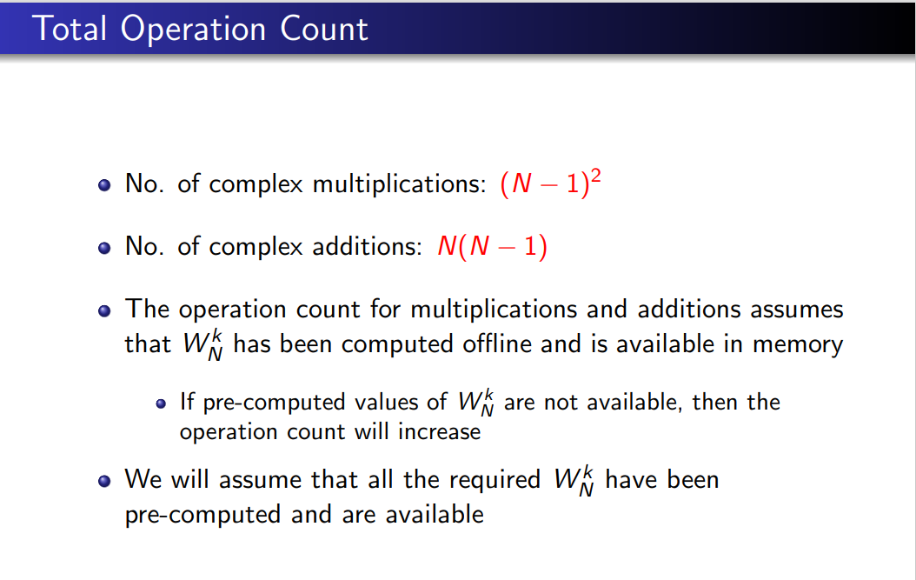

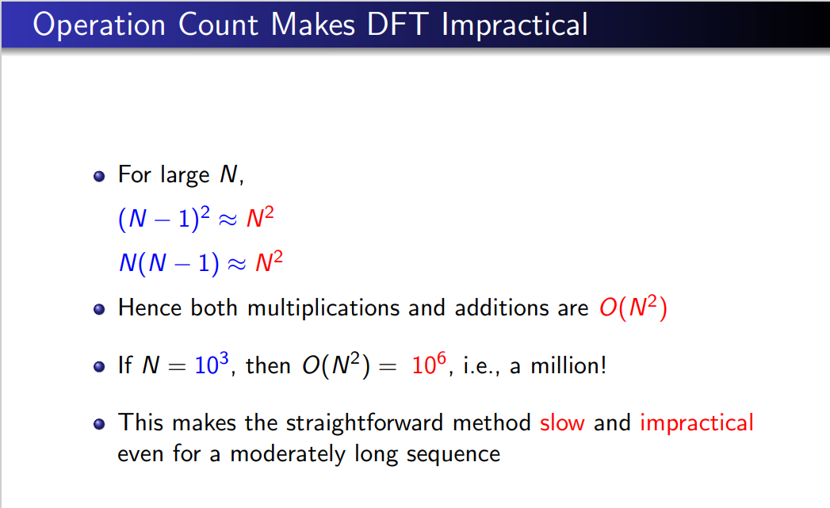

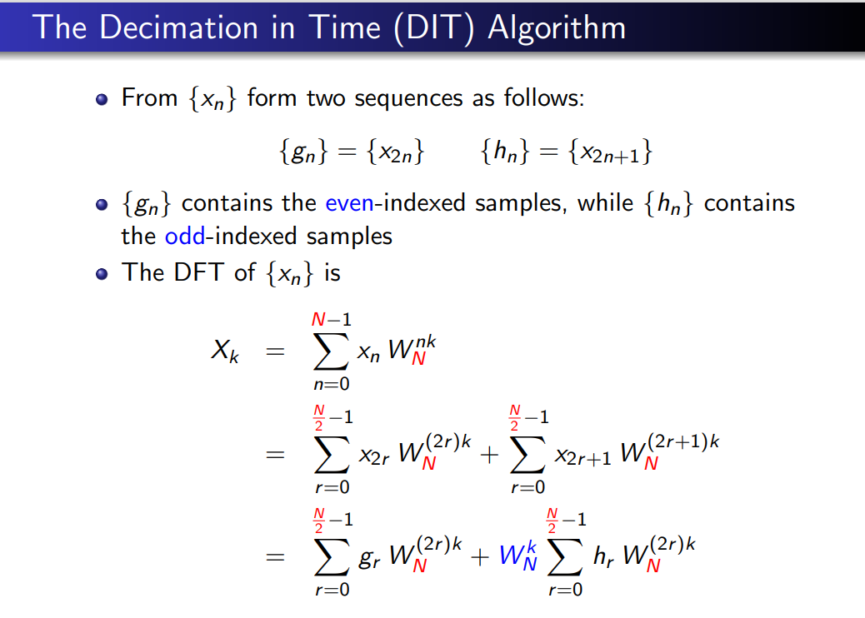

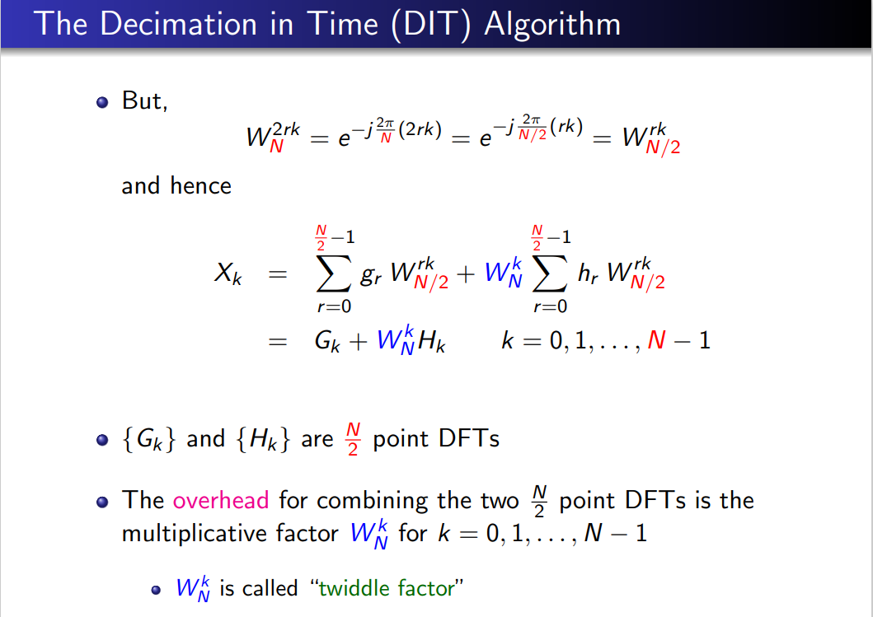

* **Can the number of computations required be reduced?**

**DFT → FFT**

* **A large amount of work has been devoted to reducing the computation time of a DFT.**
* **This has led to efficient algorithms which are known as the Fast Fourier Transform (FFT) algorithms.**

 (1)

x[n] = x[0], x[1], …, x[N-1]

* **Lets divide the sequence x[n] into even and odd sequences:**
  + **x[2n] = x[0], x[2], …, x[N-2]**
  + **x[2n+1] = x[1], x[3], …, x[N-1]**
* **Equation 1 can be rewritten as:**

 (2)

* **Since:**





* **Then:**



* **The result is that an N-point DFT can be divided into two N/2 point DFT’s:**

 **N-point DFT**

* **Where Y(k) and Z(k) are the two N/2 point DFTs operating on even and odd samples respectively:**

 **Two N/2-point DFTs**

**4 point DIT-FFT**

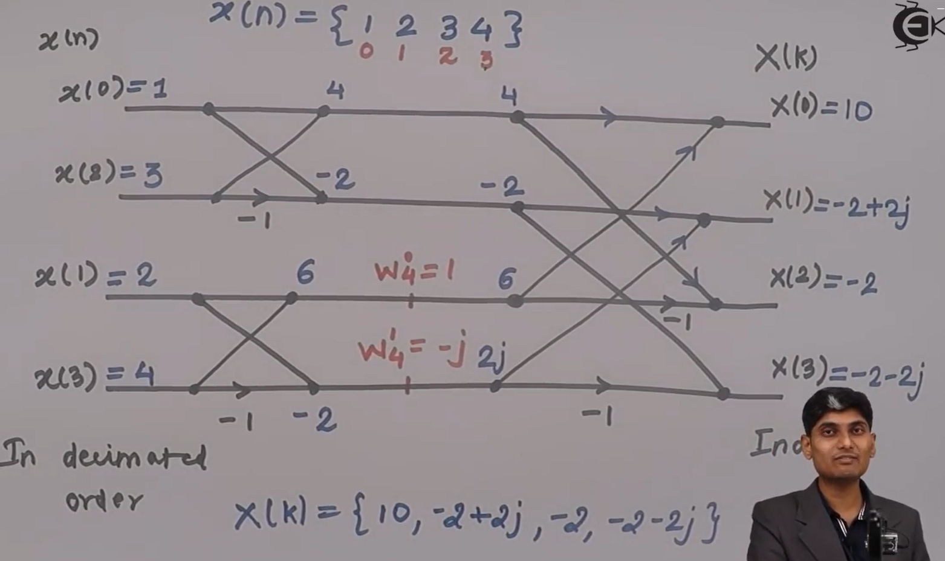

**Example 1:** Consider a sequence

Determine DFT X[k] of x[n] using the **decimation-in-time FFT** algorithm.

X=

=

=

=

=

=

=

**Example 1:** Consider a sequence

Determine DFT X[k] of x[n] using the **decimation-in-frequency FFT algorithm**.

=

=

=

=

=

=